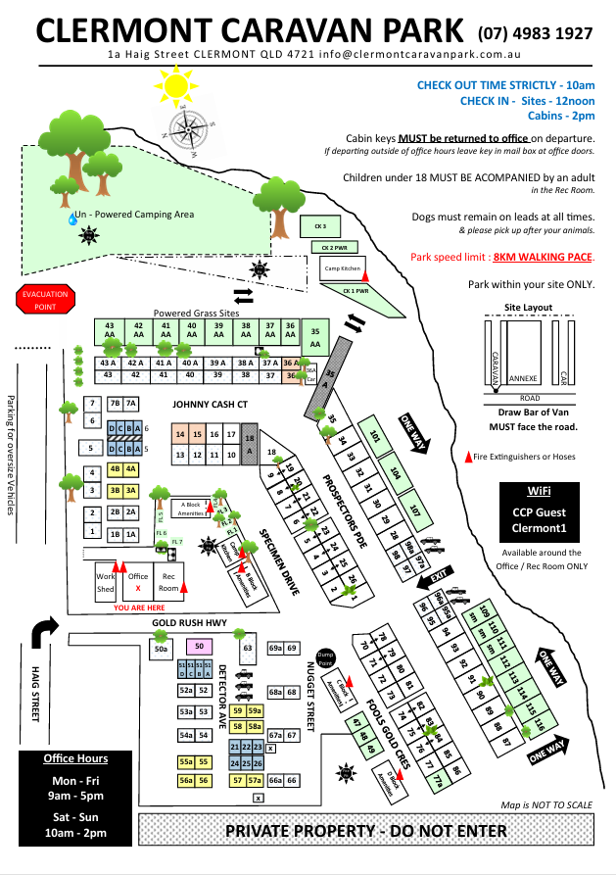
KEYS
Cabin keys are to be placed in the ‘Key Drop’ box on departure.
Check in times:
Powered Sites: Any time after 10:30AM
Cabins: After 2:00PM
All check ins: before 5:00 pm
SPEED LIMIT
Pets must be on a lead at all times.
Children under the age of 18 must be accompanied by an adult whilst in the rec room.
Office Hours
Mon – Fri
9am – 5pm
Sat – Sun
9am – 5pm
KEY DROP BOX
CHECK OUT TIME
By 10:00AM

GENERAL PARK RULES
Violation of park rules may result in you being evicted immediately & without a refund.
You are responsible for notifying the park of any damage cause to park property.
THE OFFICE IS CLOSED BETWEEN 10:00 and 10:30 AM EACH DAY AND AGAIN BETWEEW 12:30 and 1:00 PM
Management has the right to refuse entry into the park, to any person.
Drunkenness, illegal drug usage, offensive language, loud music or rowdy parties will not be tolerated under any circumstances.
As a courtesy to all guests, an 8:00 PM curfew applies across the entire park, including camp kitchens,
general park areas, van sites and cabins. The curfew will be strictly enforced & if a commotion arises the police will be notified.
All dogs must be kept on a leash whilst in the park grounds. OWNERS MUST PICK UP AFTER THEIR PET.
Children must be supervised at all times & are not permitted to ride bikes or scooters on park roads.
Only one registered vehicle per cabin or van site, visitors must park in Haig Street.
The speed limit within the park is strictly 8KM per hour or walking pace.
No mechanical repairs are to be carried out in the park grounds.
No washing of cars or vans in the park. Isaac Council has a washdown facility.
No ropes are to be attached to trees, or temporary clotheslines are not permitted.
No fires/fire pits are allowed within the park except in designated communal fire pits.
No damage to vegetation (trees or shrubs).
All garbage is to be wrapped and placed into bins provided (JJ Richard’s industrial waste bins).
Camp Kitchens are to be left clean, neat and tidy after you use it.

VAN SITES
Management takes no responsibility for the direction or the parking of vans onto sites.
Sites must always remain clean and tidy.
Sullage hoses are to be used correctly, in the appropriate drain for your site. Grass areas may run sullage onto grass.
Vans & Vehicles must be parked according to site layout, stay within your site boundaries.

CABINS
There is absolutely NO SMOKING permitted inside of cabins.
If smoking or drinking outside of your cabin, then please keep the area neat and tidy by disposing of your cigarette butts and empty cans/bottles.
Do not remove the smoke alarm from the ceiling, it is a criminal offense, notify the office if it needs a new battery.
Animals are not permitted inside of cabins unless you are allocated a pet friendly cabin.
Our cleaners are not there to do your dishes, please wash up before you vacate, all dishes, frypans, utensils etc.
Cabin air-conditioners and Televisions are to be turned off prior to vacating the cabin.
For any maintenance issue, please notify the office so that we can fix it before our next guest arrives.
For extended stays, we service cabins on a weekly basis, you will be informed as to when your cabin is being serviced. Please do not have any personal belongings lying around or on the bed.
Loss of cabin keys carry a $50 replacement fee.
BOOM GATE
Your boom gate tag needs to be placed near the reader, (on the yellow post entering the park).
If the boom gate is stuck halfway up, then you will need to place the gate tag near the reader again to re-activate the boom gate. (there is a $50 replacement fee for not returning your boom gate card).
ONLY ONE VEHICLE AT A TIME THROUGH THE BOOM GATE

You do not need your boom gate tag leaving the park, the boom gate will automatically raise.
When leaving the park and the boom gate is stuck halfway up, keep approaching the gate, it will re-activate itself. If it does not, then you will need to reverse back past the ‘Key Drop” post and try again.
PLEASE RETURN THE BOOM GATE TAG by placing it in one of the ‘KEY DROP’ boxes.

At the managers discretion a credit for days paid for can be given. Credits are not given for weather events or occurrences outside the managers control.

PLEASE ENJOY YOUR STAY and be KIND AND COURTEOUS TO OTHER GUESTS

